**L. VARSHINI**

**192372045**

**CSA1618 DWDM**

**EXPERIMENT-30**

**DESCRIPTION NUMERICAL PREDICTION ANALYSIS USING LINEAR REGRESSION THROUGH WEKA**

**AIM:**

To create description numerical prediction analysis using linear regression through weka tool.

**PROCEDURE:**

1. Download and install WEKA.
2. Open WEKA and Choose "Explorer" from the main menu.
3. Under Preprocess, Click on the open file button and select the dataset. Ensure the target variable is numerical (continuous values like price, sales, etc.).
4. Go to the Classify tab.
5. Click and Choose Linear Regression.
6. Under Test options, choose: Cross-validation (10 Folds).
7. Click Start to begin classification.

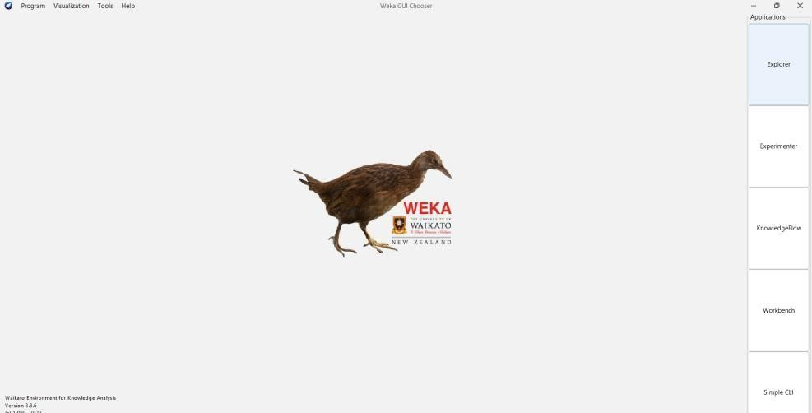

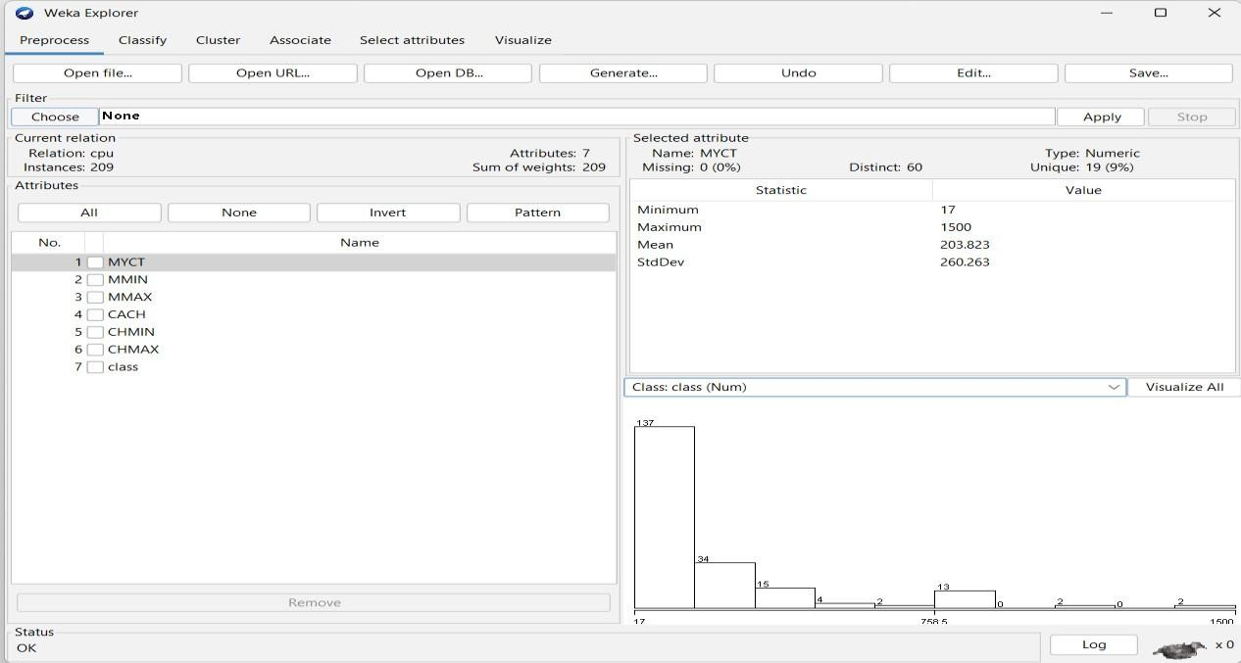

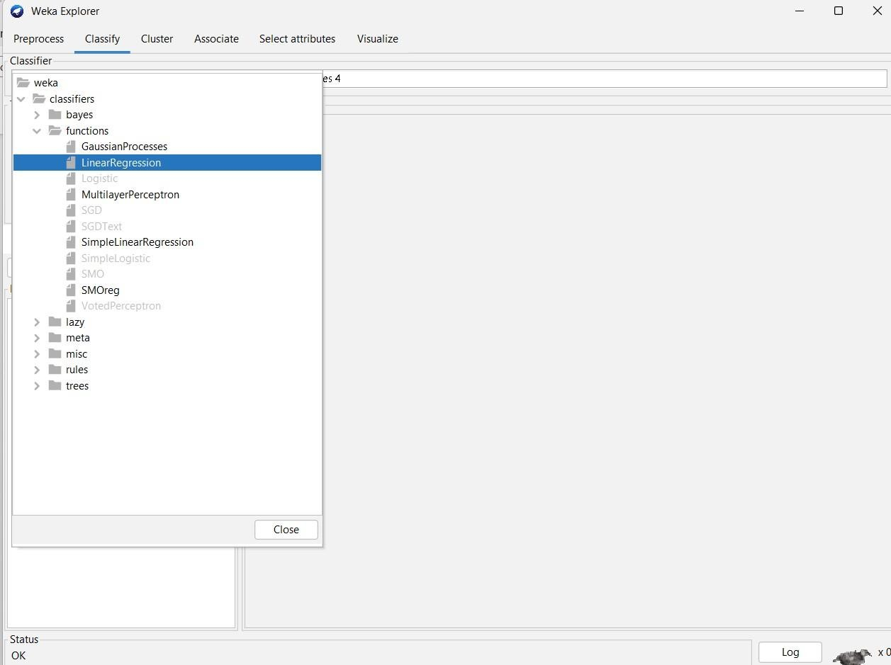

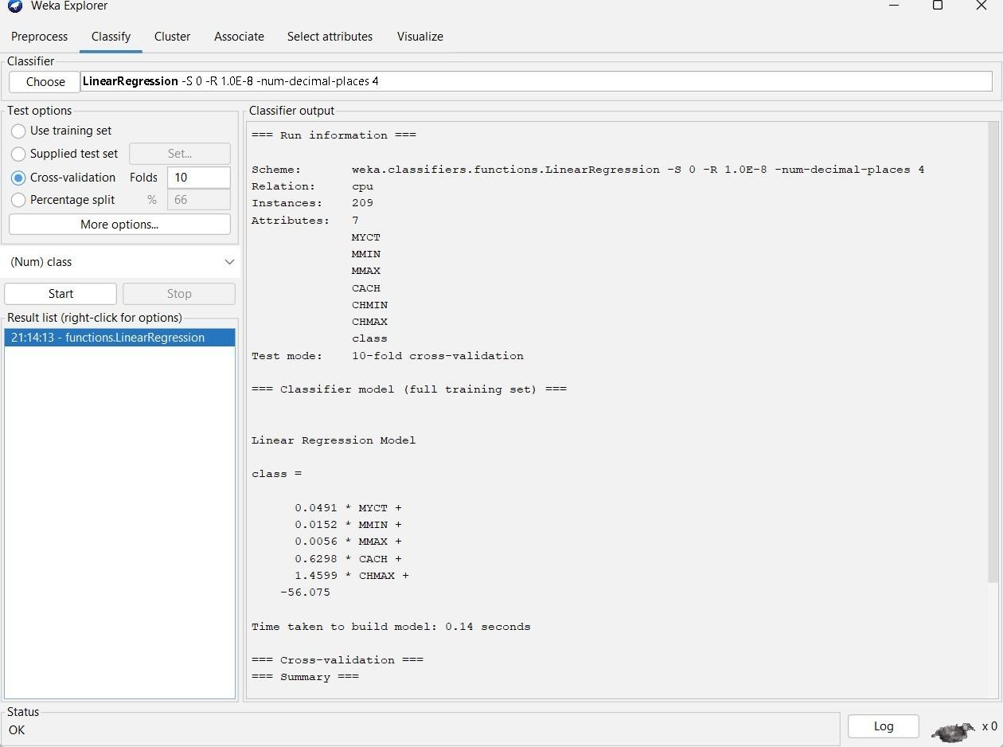

**OBSERVATION:**

Test mode: 10-fold cross-validation

=== Classifier model (full training set) ===

**Linear Regression Model** class =

0.0491 * MYCT +

0.0152 * MMIN +

0.0056 * MMAX +

0.6298 * CACH +

1.4599 * CHMAX +

-56.075

**Time taken to build model: 0.14 seconds**

=== Cross-validation ===

=== Summary ===

Correlation coefficient 0.9012

Mean absolute error 41.0886

Root mean squared error 69.556

Relative absolute error 42.6943 %

Root relative squared error 43.2421 %

Total Number of Instances 209

**RESULT:**

Thus, dataset has been observed using linear regression model. If the value of cross validation folds decreases time for creating model will be less than when folds value high, and the mean absolute error and Root mean square error values decreases with increase in the cross validation folds value.